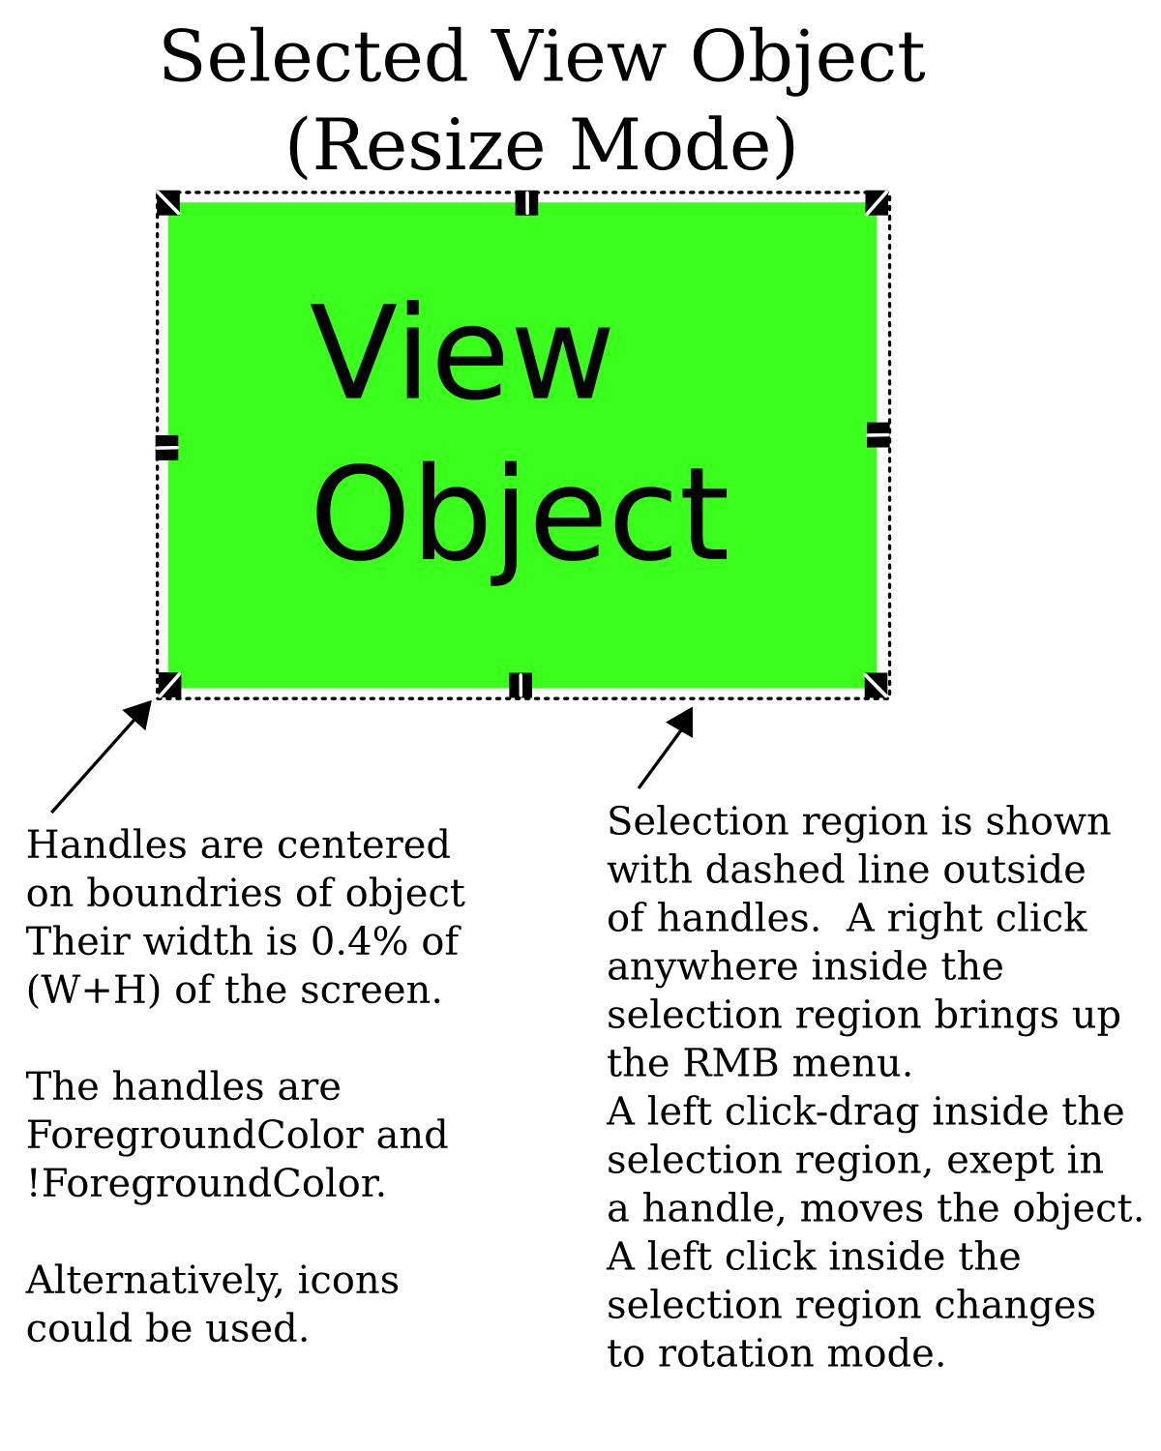
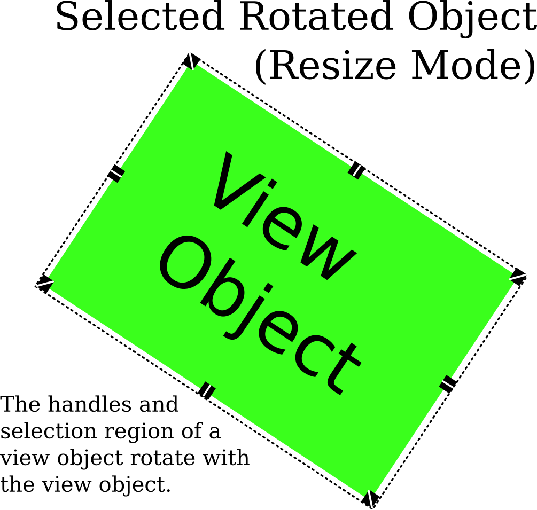
Layout Mode

Toolbars:
- There should be two mouse modes: layout mode and zoom mode, selectable from a toolbar toggle. This doc describes layout mode.
- When in layout mode, a toolbar to select the following tools should appear (there may be more):
- Label
- Box
- Plot
- Line
- Arrow
- Circle
- Ellipse
- Picture

Handles and Selection
Selection Region
- The selection region is a rectangle that extends 0.4% of (W+H) beyond the extents of the object.
- The selection region rotates with the object.
- The topmost object whose selection region contains the hot-point of the mouse is the active selection region. The selection region of the active object is indicated by a dashed rectangle. When the mouse is moved outside the selection region, the dashed rectangle disappears.
- A single left click in an active selection region selects the object, showing the handles.
- A mouse drag or a rmb click in the active selection region of an unselected object is the same as a left click (to select the object) followed by the other mouse action.

Handles for 2D objects (ie, objects other than lines):

- Selecting (with a single click) an unselected object selects it for re-size/move.
- Clicking on a selected object toggles between rotation/move mode and re-size/move mode.
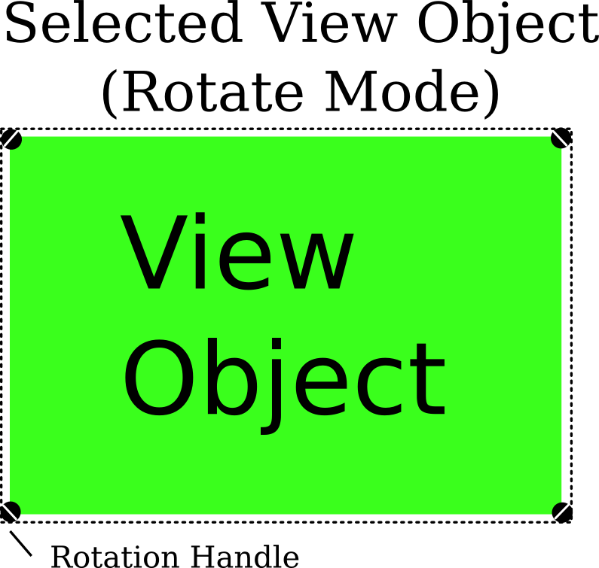
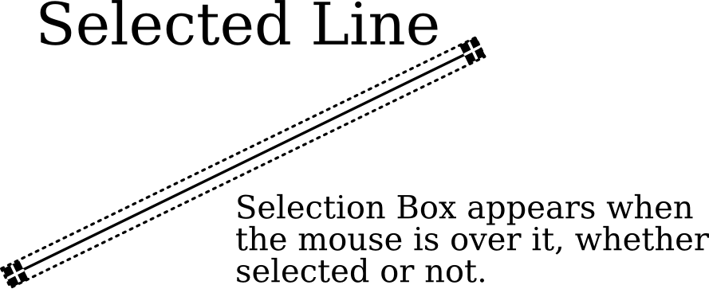
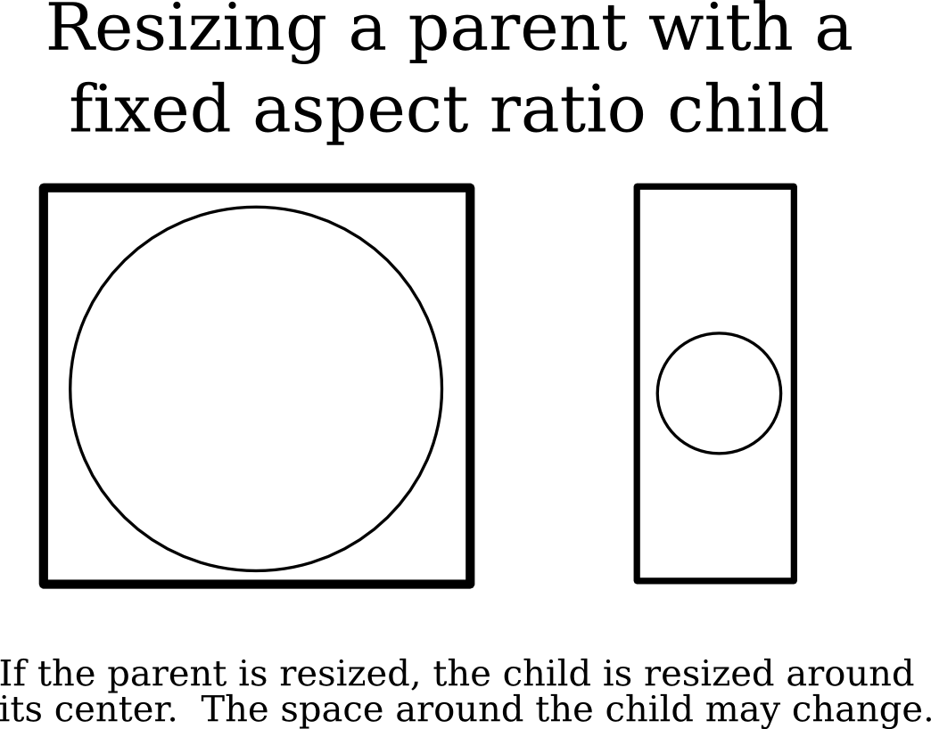
- Handle dimensions should be fixed. Ideally, their size will be fixed relative to the screen size. (but alternatively, they could be of fixed pixel size bitmapped icons).
- Handles extend outside the object so that they are accessible with objects which have been reduced to zero size.
- The mouse icon should change when it is over the handle of a selected object to indicate what a left-click-drag would do.
- The selection region and handles rotate with an object.

Handles for lines:
- A selected line has only two handles: one on each endpoint.
- Lines have no rotation mode, but changing the location of the endpoints effectively rotates the object.

Object behavior on resize and rotation:
Aspect Ratio:
- Boxes, plots, ellipses, and boxes should have a preserve aspect ratio property. For pictures, it should default on. All other objects should default off.
- Rotated rectangular objects (eg, rectangles, plots, pictures) must always preserve aspect ratio. Unsetting the option in a rotated object restores the rotation to zero. Changing the rotation sets the option.
- Text objects should always preserve aspect ratio (see 'Fonts' document).
- If the aspect ratio of the parent of an object with preserve aspect ratio set is changed, then the child object will be resized to not extend beyond the allowed space, scaling from the object's center.
- When preserve aspect ratio is set, moving the grab boxes should uniformly scale the object (but not Line Properties or font sizes).

Line properties (for all objects)
Line properties should depend on the size (width + height) of the page, but nothing else. Line properties should never depend on the aspect ratio of anything, including the page. Line properties should not change if the object is resized. Properties include:

- line widths.
- dash dimensions.
- arrow dimensions: the arrow shape should remain fixed, always.
- Ends of lines – they should be always perpendicular to line.
- Line property units should be in “points when printed to <pagesize>” (eg, US Letter). Printing to a smaller page or plot will result in thinner lines.

Rectangular objects (including legends and plots, and boxes):

- A box will always be a rectangle as displayed, even if rotated, then resized.

Mouse Based Object Creation and Manipulation:
If performance permits, objects can be displayed during mouse manipulations. This will certainly be impossible for resizing plots: but, a partial draw could be nice (just axis/labels).

Creating Rectangular objects (boxes, plots...) lines, and ellipses:
- Click-drag to draw. Object will be shown while drawing.

Creating Arrows (Special case of lines):
- Click-drag to draw the line.
- The arrow end will be located at the mouse release location.
- Arrows are lines, created with line type solid, and the end an arrow head.

Creating Circles (Special case of ellipses):
- Click drag from center to radius.
- Circles are ellipses created with with a fixed aspect ratio of 1.

Creating Labels:
- Click to location, which pops up label dialog.
- If set to 'center', the click location will be the center of the label
- If set to 'left' or 'right' the click location will be the left or right of the label.

Dialogs:
- All properties of an object will be in a single multi-tab dialog.
- Dialogs will be live, so changes will be implemented immediately.

Parenting:
- Objects will be the child of the highest object whose selection region fully encloses the child.
- Parenting will be automatically determined on move or resize of the child.
- When an object is being moved or resized, the parent which would be chosen for the object if the drag were ended will be indicated by showing the selection region of the proposed parent.

Further information:
More details on the behavior of fonts are/will be found in the Fonts document.
More details on the behavior of dialogs will be found in the Dialogs document.

